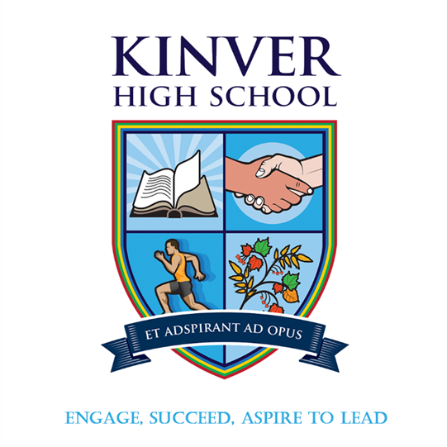

|  |
| --- |
| **YEAR 11**  **WORK EXPERIENCE**  **4th September – 8th September 2023** |

*Invictus Value 6 – Start with the end in mind*

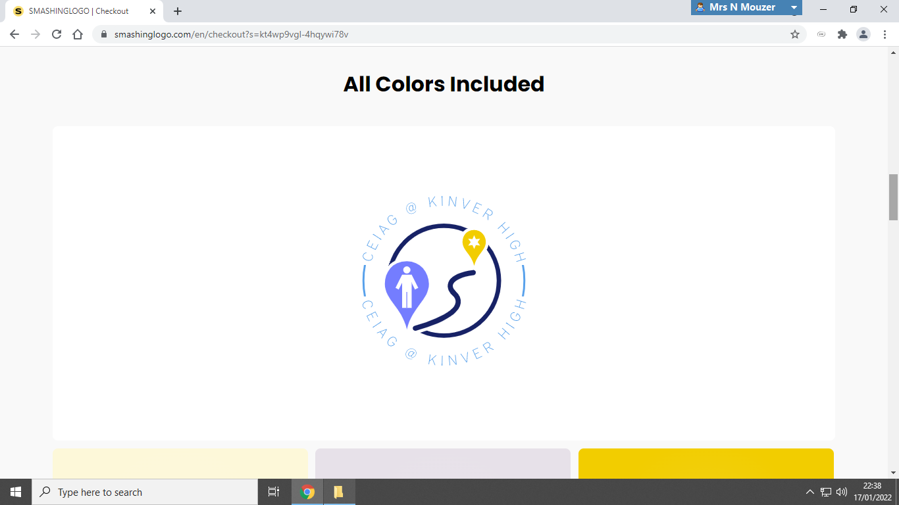

**Kinver High School and Sixth Form, Enville Road, Kinver, Stourbridge, West Midlands, DY7 6AA**

**Introduction**

Work Experience completed in the Autumn term of year 11 is a fantastic opportunity. It gives you a real insight into the world of world, allows you to gain experience in a range of different settings compared to a school and helps prepare you for the working world beyond full time education. For some students it may also help cement their decisions about future study or and help them consider their future career aspirations. Work experience offers students the chance to gain experience in a variety of situations they would not normally experience at school and is something you can add to you CV; employers look favourability on students who have completed work experience as it demonstrates that you are motivated about your future.

Work experience can provide you with:

* An insight into different careers you may be interested in.
* The chance to develop ‘employability skills’ or ‘soft skills’ that are required not only in the workplace, but in life these include communication, working with others and problem solving.
* The opportunity to ‘have a go’ in an area of potential interest
* Enable you to improve your social skills, be more independent and take on more responsibility.
* Increased self-understanding, maturity, independence and self-confidence
* Increased motivation to continue with your studies or an understanding of which study pathway to take next.
* It may lead to part-time employment or casual employment
* Valuable experience to add to you CV

**Work Experience Process**

**SCHOOL & EXTERNAL COMPANY CARRY OUT PLACEMENT CHECKS. YOU CANNOT GO ON PLACEMENT WITHOUT A PLACEMENT BEING APPROVED. SCHOOL WILL LET YOU KNOW WHEN YOUR PLACEMENT IS APPROVED OR REJECTED. WHEN YOU PLACEMENT IS APPROVED THE PROCESS WILL CONTINUE BELOW.**

Find out any important information such as dress code, start and finish time.

Contact the company up to two weeks before your placement starts to confirm the placement. Discuss any last details and know the time you need to arrive on the first day.

Get Parental Consent. You cannot take part in WEX without parental consent. *(Your parents have an email with a Microsoft forms link to complete)*

**Writing a letter asking for a work experience placement**

Although your work experience letter will always be unique to you and your situation, you should generally try to include the following:

* Who you are
* What kind of role you’re looking for
* Your overall career goals (and why this position would help)
* Your skills (or previous experience, if you have any)
* Why you’d be suitable for the role

**Opening the letter**

***Who are you, and what are you looking for?***

This section should be short, to the point, and most importantly – accurate.

Always double-check to make sure you’ve got the right address and name, and don’t forget to edit it for each organisation you send your letter to.

Give the employer a brief outline of who you are, what you’re doing (e.g. at school, university, or working), and explain what you’re looking for.

***Example:****I am a Year 10 student from Secondary School, studying GCSEs in Maths, English, and Science, alongside my chosen subjects of Textiles, Graphics, Geography, and Art.*

*I’d like to enquire about a potential work experience placement at Company Name LTD which I will be available to carry out for two weeks, from Date X-Date Y.*

**Paragraph 2**

***What are your career goals?***

This section should express a genuine interest for your chosen company and field of work, which should coincide with your career goals and ambitions.

To really stand out, show you’ve done your research, and express an interest in the company’s recent developments and successes.

***Example:****I’m keen on gaining some practical experience in a creative environment, as this is the field I’m looking to pursue a career in in the future. I’m particularly interested in working for Fashion Retail Company LTD – being an avid fan of your products (having used many of them myself). I also feel you provide excellent service and the atmosphere is positive and welcoming whenever I visit the store.*

**Third paragraph**

***Why are you suitable for the placement?***

This is your chance to sell yourself. List all of your relevant skills, and think of a real-life example to back each of them up. The examples can be from any area of your life (work, school, university), but it’s important that they accurately quantify your skills.

Then, consider your [hobbies and interests](https://www.reed.co.uk/career-advice/should-i-include-hobbies-and-interests-in-my-cv/), and assess what value they could add to your application. Are they related to the placement? Do they demonstrate any of the above skills? And are they unique enough to gain a positive reaction?

**Example:***I’m a motivated hard worker, with a creative mind and an excellent attention to detail. This can be shown in my most recent assignments for Textiles and Graphics, where I used both creativity and attention to functionality to create an children’s dress and an interactive board game – achieving an A* for each.*

*In my spare time, I volunteer at a local dance group, where I help to look after 10 children alongside a qualified dance teacher. This demonstrates my leadership skills, and ability to work well with others.*

**Closing the letter**

***Everything again (AKA Reiterate)***

Close the letter by summing up your suitability and interest in the field, and always express your gratitude for their consideration.

Keep this section short (one or two lines max), and abide by the standard letter rules when you sign off (*yours sincerely* if you know their name, *yours faithfully* if you don’t).

**Example:***As an enthusiastic student with a keen interest in what your organisation does, alongside an ability to learn new things and progress in this industry, I would be very grateful to be considered for an opportunity at Retail Fashion Company LTD.*

*I look forward to hearing from you soon.*

**Work Experience Letter/email template**

[Your name]

[Address]

[Postcode]

[Date]

[Employer’s name]

[Full address]

[Postcode]

Dear Sir/Madam [or name],

I am a [year group] student from [school name], studying [list of subjects].

I’d like to enquire about a potential work experience placement at [company name], which I will be available to carry out for [amount of time] from [start date] to [end date].

I’m keen on gaining some practical work experience in [chosen field of work], because [reasoning for pursuing a placement with this specific company and field].

I’m a [relevant skills and attributes], which can be shown in my [real-life examples that demonstrate your skills].

In my spare time, I like to [list relevant hobbies and interests], and I’ve also had some experience in/am a member of [list any groups/clubs/other work experience].

As an enthusiastic student with a keen interest in what your organisation does, as well as a passion to progress within this industry, I would be very grateful to be considered for an opportunity at [company name].

I look forward to hearing from you soon.

Yours [sincerely/faithfully]

[Your name]

**Research Log**

|  |  |  |  |
| --- | --- | --- | --- |
| Companies Researched | Would I be able to travel to this place of work for Work Experience? (Y/N) If so how. | Letter OR email sent to company (Y/N) | Placement offered (Y/N) |
|  |  |  |  |
|  |  |  |  |
|  |  |  |  |
|  |  |  |  |
|  |  |  |  |

**My notes about WEX**

*Things I want to ask…. Things I have found out…*